Software Requirements and Design Document

For

Group 24

Version 1.0

Authors:
Isaac Formato
Jack Waite
Luke Stanton
Landon Martin
Trey Corpora

1. Overview (5 points)

No More Marble Racing is a tower defense video game developed in the Godot game engine. It will consist of maps where towers can be placed alongside a path that the marbles will race down. There will be waves, currency, and various types of marbles and towers to keep the game exciting. Design aesthetic will be based on the old Marble Run style, with colorful sections of track, funnels, etc.

2. Functional Requirements (10 points)

- HIGH: The Game shall provide multiple towers for the user to purchase, sell and upgrade
- HIGH: The Game Shall have multiple marble enemy types with different speed and health values
- MEDIUM: The Game shall have a cohesive currency system, allowing users to gain money from defeating marbles and spend money on towers and upgrades
- HIGH: The Game shall have a set amount of waves, increasing in difficulty and marble variety.
- LOW: The Game shall allowed for windowed and fullscreen modes
- HIGH: The Game shall have a basic map that allows for the user to engage in all of the games systems
- MEDIUM: The Game shall allow users the upgrade towers using the currency.

3. Non-functional Requirements (10 points)
- The Game should load from the main menu to levels within a second.
- The Game should have a clean transition from windowed to full screen
- The game should securely exit with no leaks
- The game should maintain high average play times and have high player retention

4. Use Case Diagram (10 points)

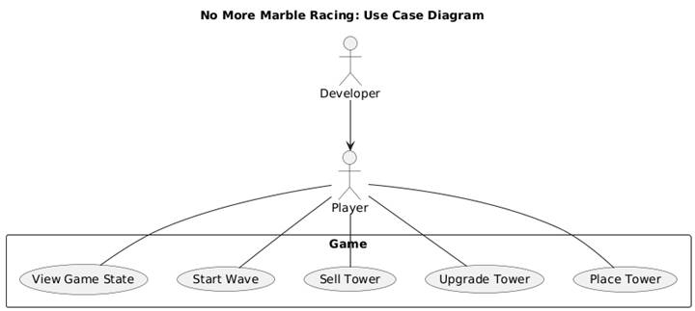

5. Class Diagram and/or Sequence Diagrams (15 points)
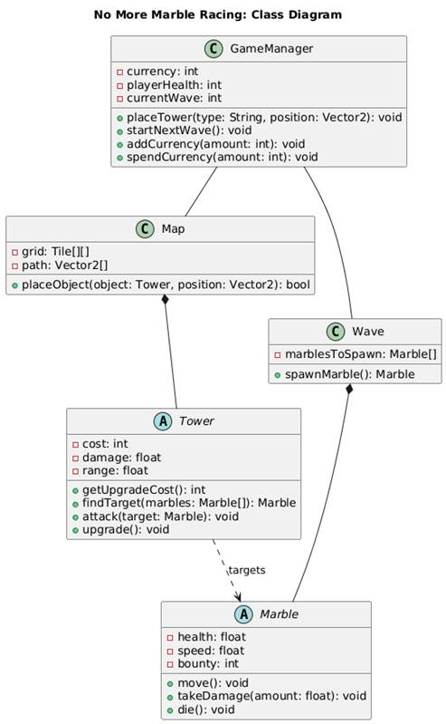
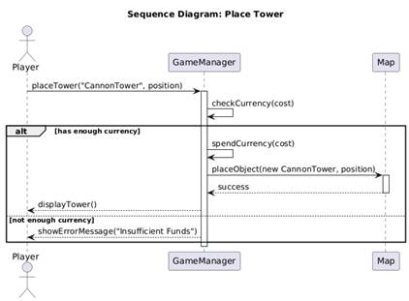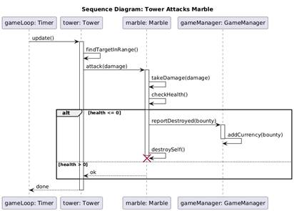

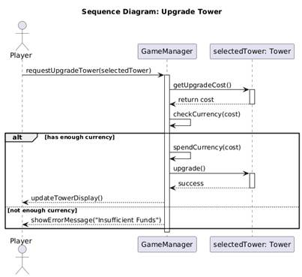

6. Operating Environment (5 points)

This software will be able to work on Linux, Windows, and Mac as a result of Godot being a cross platform game engine. Pretty much anybody will be able to run the game.

7. Assumptions and Dependencies (5 points)

In general, one should be able to run this program without a problem. The game engine does an excellent job packaging it for all OS’s. You could not expect to run this on mobile, but in reasonable use-cases on a personal computer, it will run. It is not graphically advanced.

